GIT in Eclipse
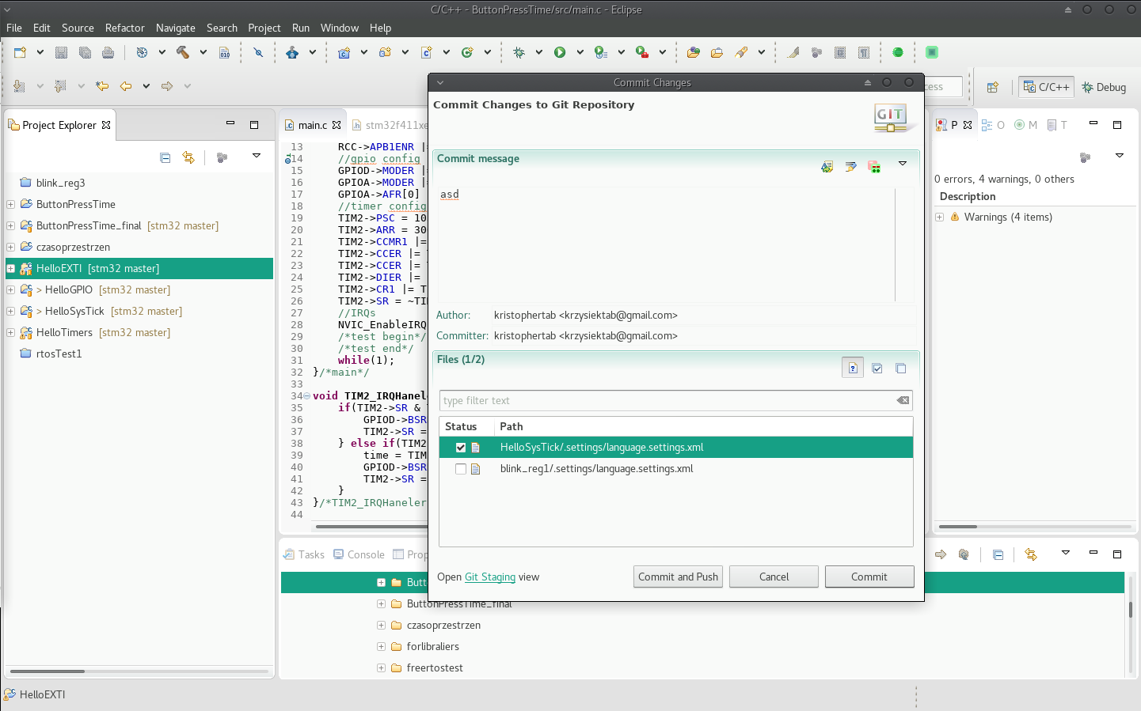
COMMIT & PUSH:
- Project Explorer: rigth mouse button on project→ Team:
- Share project
  - select .git pulled from acoount (see below)
- Commit (care about what you selected)
- Push master branch - passwords neseccary

PULL:
- right mouse button in free Project Explorer → Import
- Git→Porjects from Git
- URI, https protocol – simply
- select local folder for .git
done, some intuitive steps missed – just click next

OR:
- Open workspace directory in terminal
- run commands:
  - git init
  - git add .
  - git commit -m "comment"
  - git remote add origin <project url>
  - git push origin master
OR: open github in browser, open eclipse, Drag&Drop

